CLAP BASED FAN SWITCHING SYSTEM

Team
- Rajesh Balaji K
- Bharath K V
- Bharath Kumar S
- Mohammed Thabeeb M

Department of Electronics and Instrumentation Engineering
Velammal Engineering College

Abstract
The "Clap-Based Fan Switching System" is an efficient and cost-effective project designed to automate fan operation using sound signals, specifically the sound of a clap. This system eliminates the need for manual switches, enhancing convenience and accessibility. It utilizes a DC condenser microphone, CD4017 decade counter IC, BC547 NPN transistor, and a few resistors to detect and process clap sounds, allowing for the activation or deactivation of a DC fan. The design operates on a 5V DC supply.

Components
- DC Condenser Microphone
- CD4017 Decade Counter IC
- BC547 NPN Transistors
- Resistors
- Capacitors
- Power Supply (5V DC)
- Extra 9V Battery

Model:

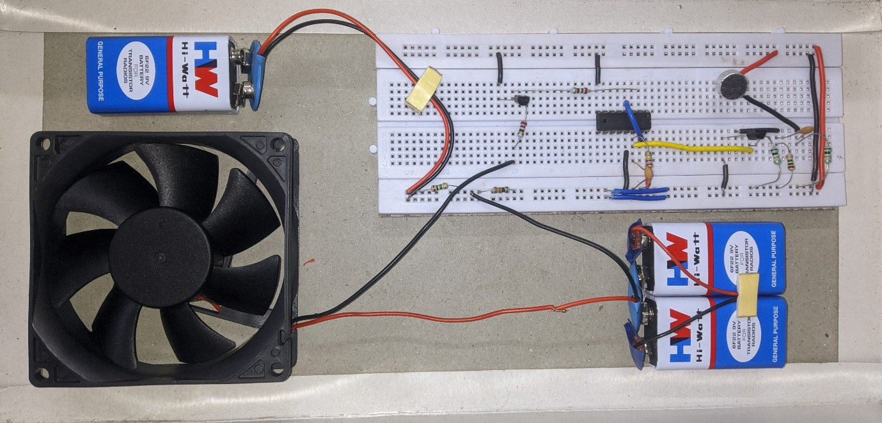

Introduction
Automation is a significant trend in today's world, simplifying daily tasks. A clap-based switching system automates the control of electrical devices, such as fans, using sound detection. This project provides a practical implementation of a clap-based fan control system. The system relies on a sound sensor to detect clap sounds and utilizes a decade counter IC (CD4017) to toggle the fan's state. It is ideal for home automation applications and can be easily expanded to control multiple devices. This presentation will explore the underlying technology, key components, and potential applications of clap-based fan switching, highlighting how this effective solution can improve daily life.

Proposed Methodology
- Sound Detection: A DC condenser microphone captures the sound of a clap, which is then amplified using a BC547 transistor.
- Signal Processing: The amplified signal is sent to the clock input of the CD4017 decade counter IC, incrementing its count with each detected clap.
- Control Logic: The CD4017 outputs a logic high signal on its Q0 pin for the first clap and on Q1 for the second. These outputs toggle the fan's state (on/off).
- Switching Mechanism: A relay or transistor controls the DC fan, connected to the Q0 and Q1 outputs of the CD4017 IC.
- Power Supply: The entire system is powered by a 5V DC supply, ensuring low power consumption.

Block Diagram
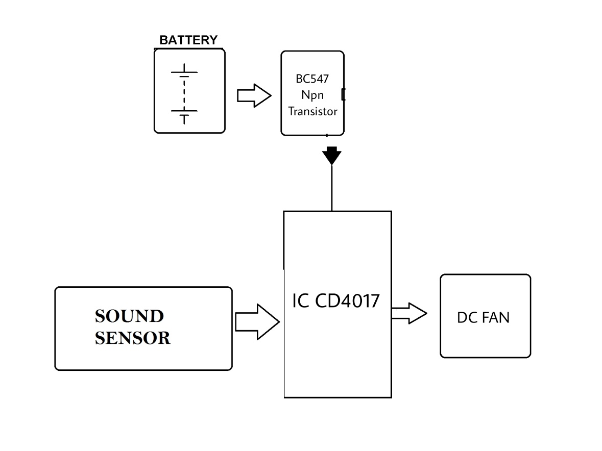

Circuit Diagram

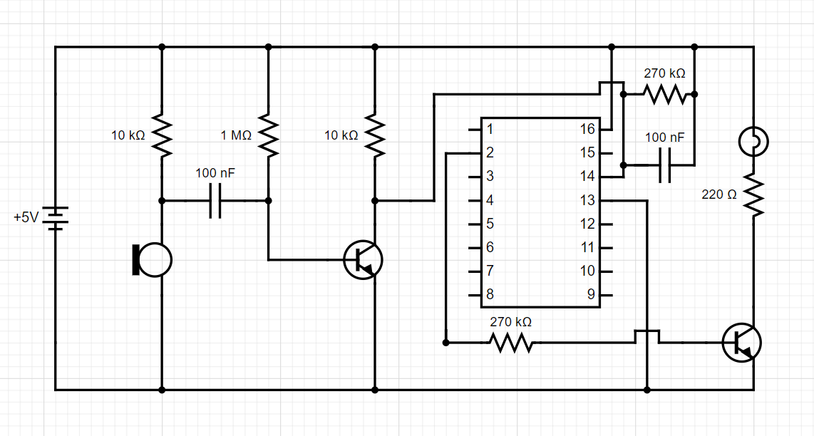

Results
Clap-based fan switching systems utilize sound detection to control electrical appliances, such as fans. Here’s a summary of how they function:
- Microphone Detection: A microphone captures sound and converts it to an electrical signal.
- Signal Processing: The system processes the signal to detect the frequency and intensity of claps, using a threshold to differentiate claps from background noise.
- Control Logic: Upon detecting a clap, the system triggers a relay or microcontroller to turn the fan on or off.
- User Interaction: Generally, one clap turns the fan on, while two claps turn it off, although this can vary by design.

Benefits
- Convenience: Ideal for individuals with mobility issues or when hands are occupied.
- Energy Efficiency: Reduces unnecessary power usage.

Challenges
- False Positives: Other loud noises may inadvertently activate the fan.
- Limited Control: May not provide speed control or additional functionalities without extra programming.

Conclusion
In conclusion, clap-based fan switching systems offer an innovative and convenient solution for controlling appliances with minimal physical effort. They enhance accessibility, making it easier for individuals with mobility challenges to operate fans. While these systems are generally easy to use, they face challenges such as potential false activations and limited functionality regarding speed control. Overall, integrating clap-based technology into home automation represents a step toward more intuitive living spaces, merging convenience with modern technology. As advancements continue, we can expect improved accuracy and additional features, making these systems even more user-friendly and reliable.

